Analysis model – version 2

Object catalog

4.1.1 Game
Game is the object, that controls the flow of the application. It knows which stage should be loaded next, loads it and ends it if certain conditions are met. Game also keeps track of the progress of the player. (levels cleared, levels left)

Responsibilities:
- Starts the game
- Loads next stage
- Finishes the game

Interacts with:
- Table
- Train
- Player

4.1.2 Player
Player is the object that gives commands to all the other game objects. It can ask Game to load the next level or to end the current one. Player controls the movement of the train, by setting the position of the switches and by creating or dismantling tunnels.

Responsibilities:
- Controls switches
- Controls tunnels

Interacts with:
- Switch
- Tunnel
- Game

4.1.3 Train
The train is the main object of the game. Its movement determines the outcome of the game. By itself. it can move on the railroads with a constant speed. It consists of the engine and several passenger cars. Trains main responsibility is to deliver passengers to the corrects stations. The train cannot decide on the path it will take it is completely controlled by the player.

Responsibilities:
- Moves on railroads
- Transports the passengers

Interacts with:
- Railroad
- Stations
- Tunnels
- Engine
- Cars
- Passenger
- Game
4.1.4 Engine
Engine is a leading part of the train. It doesn’t have color or passengers on its own. Whenever the train moves forward on the rail, engine is the first part of the train that comes into contact with the new object: rail, station, switch or a tunnel. If the Engine comes into contact with the entrance of a tunnel, train enters that tunnel. If the engine comes into contact with the switch train takes the new direction in accordance with the switch.

Responsibilities:
- Moves on railroads
- Leads the train

Interacts with:
- Railroad
- Train
- Field

4.1.3 Car
A car is a part of the train. It has a color and may or may not contain passengers. By itself, a car performs the discharge of the passengers, which is its main responsibility. When a train comes in contact with the station, a car must determine if the color of the station matches its’ own color. If so, it will discharge the passengers (if not already empty). Other objects don’t interact with the car directly.
Responsibilities:
- Transports the passengers
- Follow the engine
- Check the compatibility with the station
- Discharge passengers

Interacts with:
- Railroad
- Train
- Engine
- Passengers
- Stations

4.1.5 Switch
Switches are present at the interjections of the rails. It defines how the intersecting rails are connected with each other. Player can change the direction of the switch. If the Engine of the train comes into contact with the switch the train takes the direction defined by the switch.
Responsibilities:
- Connects railroad parts
- Directs the trains

Interacts with:
- Railroad
- Train

4.1.6 Tunnel
A Tunnel occupies the certain spots on the table. It can create a new path for the train to take. When a train enters a tunnel, it knows that it should follow a path which is topologically different from the visible (surface) railroad and emerge on the other side of the tunnel.

Responsibilities:
- Connects railroad parts
- Directs the trains

Interacts with:
- Railroad
- Train

4.1.6 Station
Station is the part of the rail system. Trains moving on a rail could end up at the station. Every station has an associated color. If the train car comes into contact with the station that has corresponding color, passengers from the car leave the train and are accepted by the station.

Responsibilities:
- Accepts passengers

Interacts with:
- Train
- Table
- Game

4.1.7 Passenger
Passengers exist inside the cars of the train. After the train enters the station matching their car color. They are no longer part of the car.

Responsibilities:
Travel on trains

Interacts with:
Train
Station

4.1.8 Table/Map

Table/Map is the container object for the level. it contains the rails, switches, tunnels and train in a structured manner.

Responsibilities:
- Contains fields

Interacts with:
- Fields
- Stations
- Game

Class description

4.2.1 Game
· Responsibility
The Game is a singleton class that manages the global state of the game. It contains the collection of stages and is responsible for loading new stages and managing its lifecycle.
· Superclasses
This class has no superclass.
· Interfaces
This class doesn’t implement any interface.
· Attributes
- Stage stages[] - Collection of the stages. As the player progresses in the game, we choose next stage from this collection.
- Stage currentStage - current active stage.
· Methods
- void startGame() - This method sets up all the necessary data structures for the game to start. It loads the stages into memory and launches the first stage.
- void nextLevel() - This method unloads the current stage and loads the next one from the stages collection.
- void endGame() - This method is run when the game is finished.
- void addStage(Stage s) - Add stage to the stages array.
4.2.2 Stage
· Responsibility
Stage class holds the state of the current Stage: It contains all the fields that make up the map and the current passenger count.

Superclasses
This class has no superclass.
· Interfaces
This class doesn’t implement any interface.
· Attributes

- int passengerCount - Aggregated passenger count of all the PassengerCar’s passengers. If this value goes down to 0, player wins the stage.
- Field fields[] - The stage is made up of multiple fields situated next to each other. This collection contains all the fields belonging to the stage.

· Methods

- void passengerDelivered() - Every time PassengerCar delivers a passenger this method is called.
- void addField(Field f) - adds field to the field array.
- vod setPassengerCount(int p) - sets the passenger count.
4.2.3 Field
· Responsibility
Field is the atomic part of the Stage. Every stage is made up of fields situated next to each other on all directions (up, down, left, right). Fields can accept Car’s from the neighboring field and execute corresponding action, depending on the type of Field.
· Superclasses
This class has no superclass.
· Interfaces
This class doesn’t implement any interface.
· Attributes
- Field entrance1 - Every field has two neighboring fields from which the train may end up in the current field. attributes enetrance1 and entrance2 contain those neighboring fields.
- Field entrance2
- Stage stage - The stage that the field belongs to.
- Car cars[] - Collection of the cars that the field is holding. Only tunnels can hold more than one cars at the same time.
· Methods
- void acceptCar(Car c, Field from) - accept car from one of the entrance. We need to know the exact entrance in order to determine the direction of the car ( which neighboring field it should move next)
- void removeCar() - remove car from the current field. This function is called when the car moves away from the field.
- Field getDirection() - Considering the current car and the direction it came from, this function returns the field onto which the car should go next.
4.2.4 RailRoad
· Responsibility
RailRoad is the simplest type of the field of the Stage. On every tick cars move on one RailRoad Field. It has two entrances and can only hold one car at a time.
· Superclasses
Field
· Interfaces
This class doesn’t implement any interface.

· Attributes
This class has no attributes of it’s own.
· Methods
- void acceptCar(Car c, Field from) - accept the car to the current Field. If the current Field is not occupied this function succeeds..
- void removeCar() - remove Car from the current Field.
- Field getDirection() - Considering the current car and the direction it came from, this function returns the field onto which the car should go next.
4.2.5 DeadEnd
· Responsibility
Deadend is the type of Field that has only one entrance without any exit. If the engine enters the DeadEnd it loses the game.
· Superclasses
Field
· Interfaces
This class doesn’t implement any interface.
· Attributes
This class doesn’t implement any attribute.
· Method
- void acceptCar(Car c, Field from) - If this method is called by any Car the game is over.
- void removeCar() - remove Car from the current Field.
- Field getDirection() - returns None
4.2.6 Switch
· Responsibility
Switch is one of the most important Field type. It has multiple entry points, but only two of them are active at any given time.
· Superclasses
Field
· Interfaces
This class doesn’t implement any interface.
· Attributes
- Field directions[] - all the fields that can be chosen as a possible entrance to the Field.

· Methods
- void acceptCar(Car c, Field from) - accept car from one of the entrance. We need to know the exact entrance in order to determine the direction of the car ( which neighboring field it should move next)
- void removeCar() - remove car from the current field. This function is called when the car moves away from the field.
- Field getDirection() - Considering the current car and the direction it came from, this function returns the field onto which the car should go next.
- void changeDirection() - User changes the direction of the switch. two of the entrances can be chosen from the directions array.
- void addDirection(Field f) - adds the field to the directions array.
4.2.7 Tunnel
· Responsibility
Tunnel is the type of the Field that can “teleport” train from one Field to another that is not adjacent to it.
· Superclasses
Field.
· Interfaces
This class doesn’t implement any interface.
· Attributes
- Tunnel exitTunnel - The tunnel from which the train will emerge once it entered the tunnel.
- boolean isActive - this attribute shows whether the user has activated the Tunnel.
- Field tunnelEntrance - The entrance field of the Tunnel.
· Methods
- void acceptCar(Car c, Field from) - Accept the car to the tunnel.
- void removeCar() - remove car from the current field. This function is called when the car emerges from the other side of the tunnel.
- Field getDirection() - Considering the current car and the direction it came from, this function returns the field onto which the car should go next.
- void setTunnelEntrance(Field f) - sets the tunnel entrance.
- void setExitTunnel(Tunnel t) - sets the exit tunnel.
- void activate() - Activate the tunnel.
- void deactivate() - Deactivate the tunnel.
4.2.8 Station
· Responsibility
Station acts as an ordinary RailRoad, except if certain conditions are true, passengers can depart the Car that enters the Station Field.
· Superclasses
Field.
· Interfaces
This class doesn’t implement any interface.
· Attributes
- Color color - color of the station.
· Methods
- void acceptCar(Car c, Field from) - Accept car, if the type of the car is PassengerCar and all the previous Cars are empty, passengers leave the current car.
- void removeCar() - Remove car from the cuurent Field.
- Field getDirection() - Considering the current car and the direction it came from, this function returns the field onto which the car should go next.
- void setColor(Color c) - sets the color of the station.
4.2.9 Car
· Responsibility
Car is the abstract class that is the parent class of Engine and PassengerCar.
· Superclasses
This class has no superclass.
· Interfaces
This class doesn’t implement any interface.
· Attributes
- Car nextCar - stores the reference to the next car.
- bool isVisible - this attribute shows whether the car visible
- Field field - The Field that the car belongs to.
Methods
- Field getField() - get the Field the car is currently on.
- void setField(Field f) - set the Field for the current car
- void setVisible() - set the visibility of the car.
- void setNext(Car nc) - sets the next car reference.
- void setInvisible() - set the visibility of the car.
- void activate() - activate the Car.
- void removePassanger(Station s) - remove passangers from the car, if the color of the car matches that of the station.
- void moveTo(Field f) - move car to the given field.
4.2.10 Engine
· Responsibility
The Car that leads the train. Unlike PassengerCar engine doesn’t contain any passengers.
· Superclasses
Car
· Interfaces
This class doesn’t implement any interface.

· Attributes
This class has no attributes.
· Methods
- void move() - moves the engine on every tick of the timer (according to the given direction).
- void collide() - detects the collision after move.
- void activate()
- void removePassenger(Station s)
- void moveTo(Field f)
4.2.11 PassengerCar
· Responsibility
The type of the Car that can transport passengers. It has associated color and in case this case ever ends up on a Station Field that matches it’s color passengers leave the Car.
· Superclasses
Car.
· Interfaces
This class doesn’t implement any interface.
· Attributes
- Color color - Color of this PassengerCar.
- int passangerCount - Number of Passengers.
- bool isActive - is set to true if all the passenger cars ahead of it are empty and it still contains passengers
· Methods
- void activate() - Activate the current car.
- void removePassanger() - Remove the passenger from the current Car.
- void setColor(Color c) - sets the color of the passenger car.
- void setPassengerCount(int c) - sets the passenger count.
- void activateNextCar() - activates the next car.
- void moveTo(Field f) - moves to the given field.

4.2.12 Timer
· Responsibility
The main timer of the game. On Every tick every engine makes a move.
· Superclasses
This class has no superclass.
· Interfaces
This class doesn’t implement any interface.
· Attributes
- Engine engines[] - List of the engines on the Stage.
· Methods
- void tick() - Tick that fires moves on every engine in the engines collection.
- void addEngine(Engine e) - adds engine to the engines array.

4.2.13 Color
· Responsibility
This enum holds the possible colors for the PassangerCar and Stations.
· Superclasses
This enum has no superclass.
· Interfaces
This enum doesn’t implement any interface.
· Attributes
- Red
- Pink
- Green
- Orange
- Blue
- Yellow

Static structure diagrams

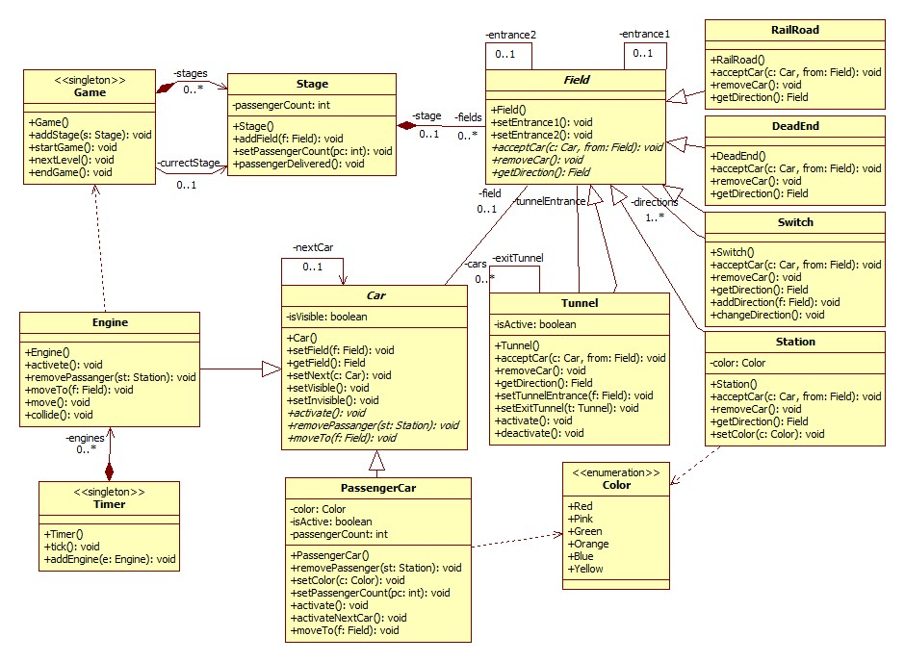

Sequence diagrams

Next Level
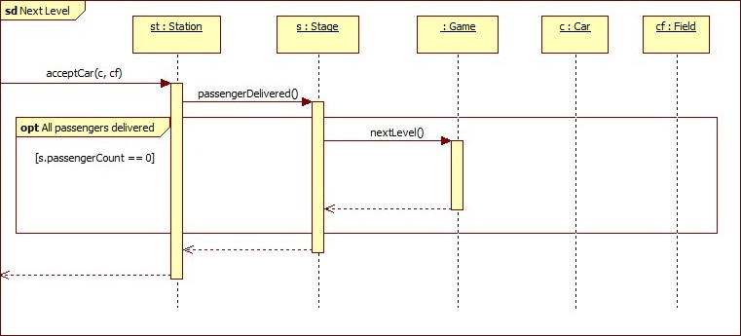

End Game

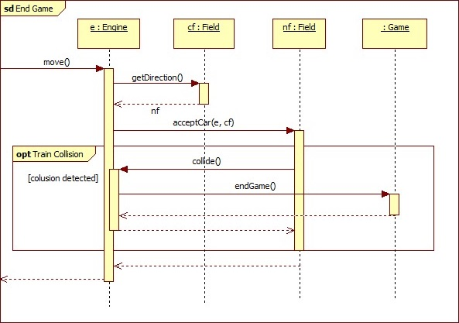

Timer Tick
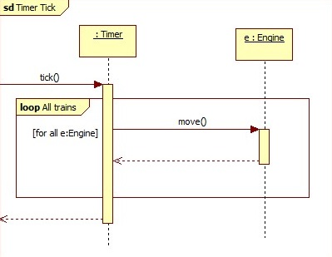

Engine Initialization
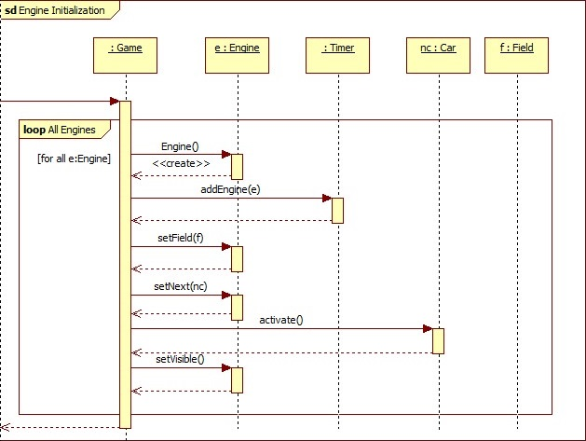

PassangerCar initialization
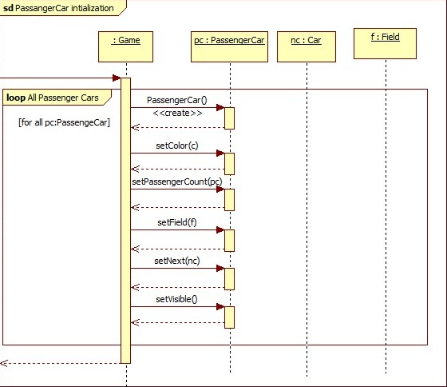

Train Move

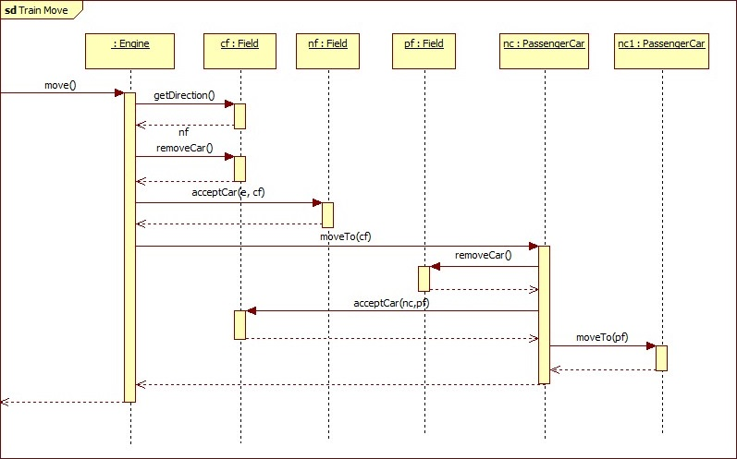

Passenger Arrived
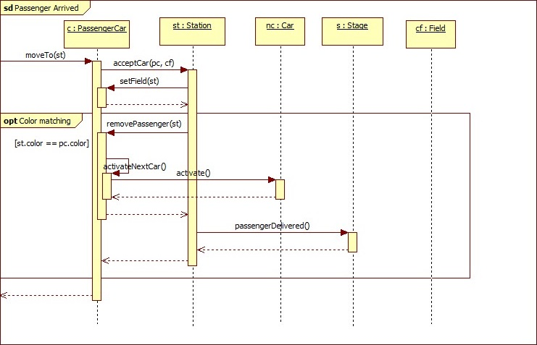

Railroad initialization
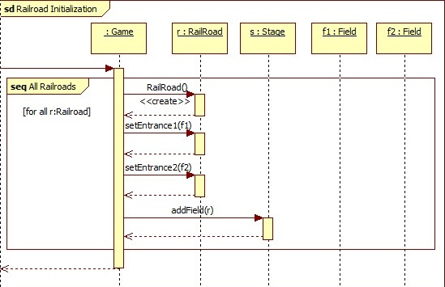

DeadEnd initialization
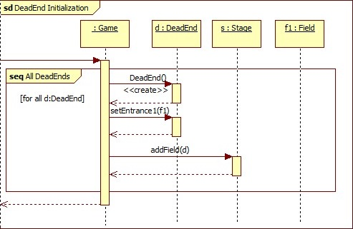

Switch Initialization
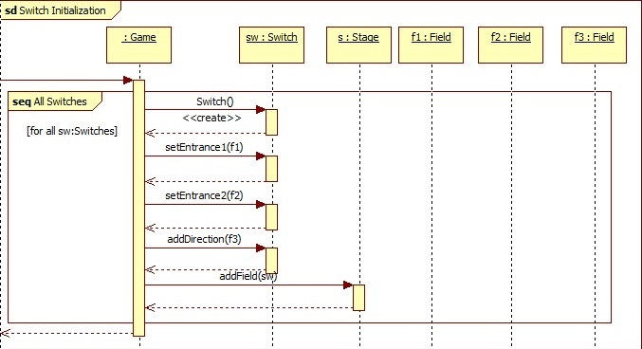

Switch Modification
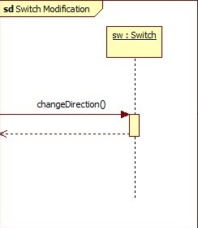

Station Initialization
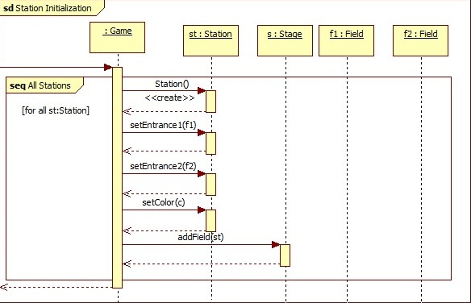

Tunnel Initialization
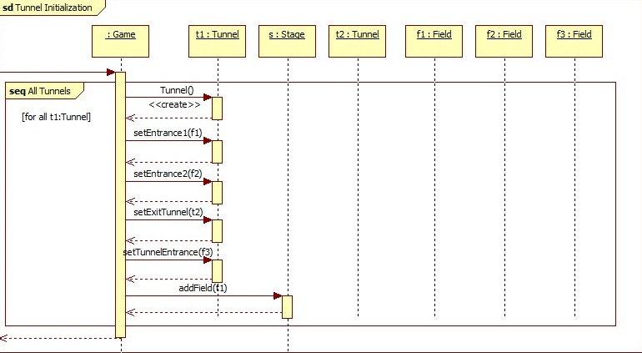

Tunnel Activation

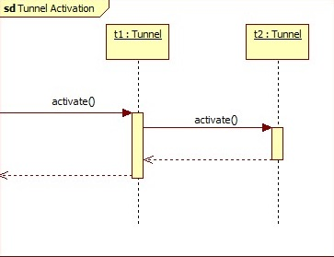

Tunnel Deactivation

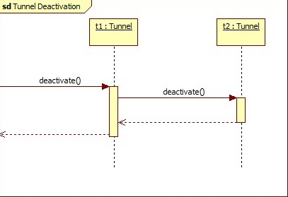

Tunnel Enter
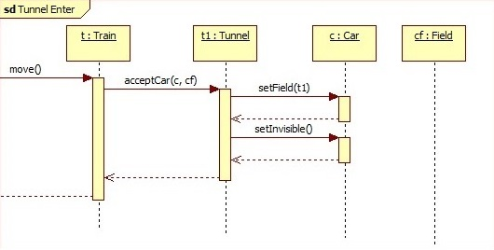

Tunnel Exit
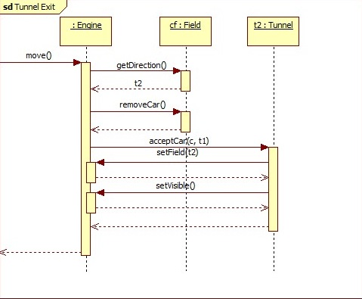

State-charts

Tunnel state
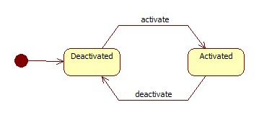

Car state
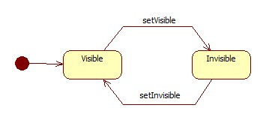

Protocol

Start (date & time) | Duration (hours) | Performer(s) name | Activity description
18.02.2019 10:00 | 2 hours | Mikheil Tabidze, Yasir M. Suliman A. | Consultation with course lecturer Dr. Katalin Balla
21.02.2019 16:30 | 1 hour | Irakli Vashakidze, Mikheil Tabidze, Shota Osepashvili | Meeting. Decisions:  Irakli Vashakidze is responsible for the preparing 3.1 Object catalog, the deadline is 24.02.2019  Mikheil Tabidze is responsible for the preparing 3.4 Sequence diagrams, the deadline is 24.02.2019  Shota Osepashvili is responsible for the preparing 3.2 Class description, the deadline is 24.02.2019
22.02.2019 12:00 | 1 hour | Irakli Vashakidze, Mikheil Tabidze, Shota Osepashvili, Yasir M. Suliman A., Yekaterina Ussacheva | Meeting. Decisions  Yasir M. Suliman A. is responsible for the preparing 3.5 State-charts and Corrections, the deadline is 24.02.2019  Yekaterina Ussacheva is responsible for the preparing 3.3 Static structure diagrams, the deadline is 24.02.201
23.02.2019 10:00 | 4 hours | Irakli Vashakidze | Preparing 3.1 Object catalog
23.02.2019 12:00 | 4 hours | Mikheil Tabidze | Preparing 3.4 Sequence diagrams
23.02.2019 10:00 | 4 hours | Shota Osepashvili | Preparing 3.2 Class description
23.02.2019 18:00 | 3 hours | Yasir M. Suliman A. | Preparing 3.5 State-charts
23.02.2019 14:00 | 3 hours | Yekaterina Ussacheva | Preparing 3.3 Static structure diagrams
25.02.2019 10:00 | 0.5 hour | Irakli Vashakidze, Mikheil Tabidze, Shota Osepashvili, Yasir M. Suliman A., Yekaterina Ussacheva | Meeting. Submission of 3. Analysis model – version 1

